LEVANTINE JOURNAL OF APPLIED SCIENCES

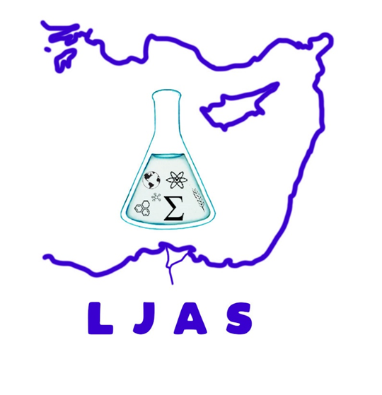
December, 2025

CONTENTS
Original Article

Merve AYYILDIZ and Melek CAN

Evaluation of Consumer Views on Fresh Fruit and Vegetable Waste in Households: Yozgat Central District Example

Pages: 15 – 20

