LEVANTINE JOURNAL OF APPLIED SCIENCES

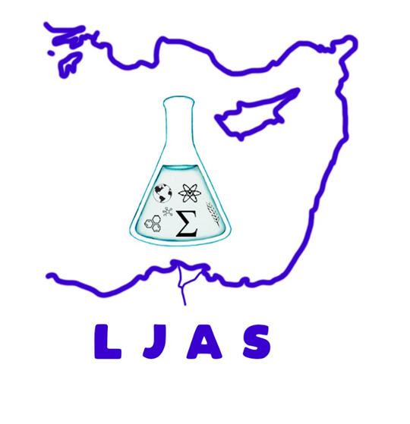
JUNE, 2022

CONTENTS
Original Articles

Melek GÖKBULUT and Şeyda AŞCI
Analytically Evaluation of Bose-Einstein Type Integral by the Binomial Series Expansions
Pages: 1 - 5

Hikmet GÜNAL, Miraç KILIÇ, Mesut ALTINDAL, Recep GÜNDOĞAN
Rapid Spatial Estimation of Soil pH using Machine Learning under Limited Covariate Conditions
Pages: 6 – 13

Nejdet KANDEMİR
Stability Analysis of Lines Selected from a Barley Landrace under Rainfed Conditions
Pages: 14 – 19

