LEVANTINE JOURNAL OF APPLIED SCIENCES

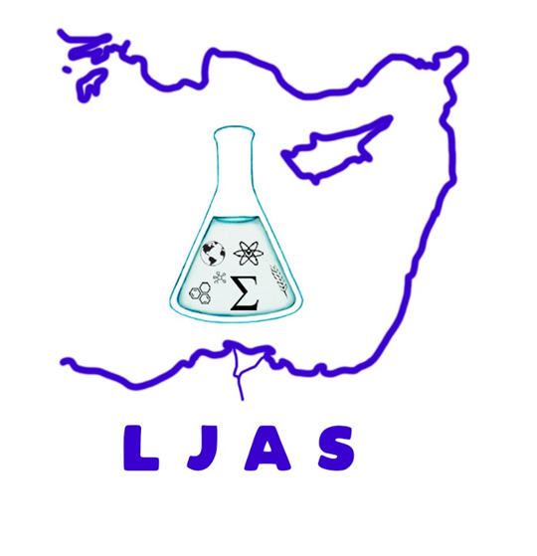
JUNE, 2023

CONTENTS
Original Articles

Fikret YILMAZ and Fatih YASAR

What is the reason of size effect on the hardness and reduced modulus of melt-spun Al-12Si-0.5Sb alloy in the indentation test?

Pages: 1 - 6

Melek GÖKBULUT
Calculation of the Heat Capacity of Silicon Dioxide
Pages: 7 – 11

